**IBM Business Validator(REST API)**

**IDE**: Eclipse Oxygen

**JDK/JRE:** 1.8+

**Framework:** SpringBoot

**Project Type:** Maven Project

**Folder Structure:**

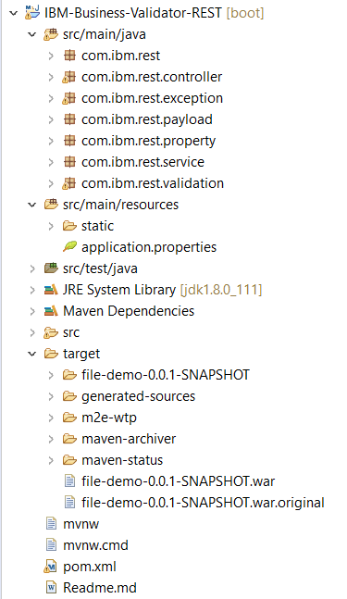

* *com.ibm.rest contains the application startup code that will help in driving the application.
* *com.ibm.rest.controller contains the controller class that helps in mapping the web pages to the browser. It is also the parent class from which the subsequent classes are linked with.
* *com.ibm.rest.exception has been used to create user defined exceptions.
* *com.ibm.rest.payload contains a class for getter setter functions
* *com.ibm.rest.property contains a class that has getter setter methods for the upload directory. This class fetches values from Configuration properties annotation.
* *com.ibm.rest.service contains a class that is used for storing file and checking whether a valid file is being uploaded or not.
* *com.ibm.rest.validation contains 2 major classes that combine to perform the PEPPOL validation on the uploaded file and stores the generated report in a zip format.

**Note:**

Apart from these, the static folder contains the css and html for JS that is used as a frontend and application properties contains the properties that are applicable to the uploaded files. **It is under this that the file uploading directory is given.** Also make sure you have satisfied all dependencies in the pom.xml file.

The target folder contains the war file for the same. To create a war file, Go To **Project-> Run as-> Maven build..** . Under Goals in Edit configuration type **clean install and Run.**  Your war file will be created in the target folder.

SpringBoot does not require any Tomcat configuration to be made externally to run on Eclipse. It comes with an in-built Tomcat Configuration.

**POSTMAN calls:**

Run your SpringBoot project and open **POSTMAN.**

Enable the post request and in the URL section type: <http://localhost:8080/uploadFile>

Make sure you have provided fields in the body section and disabled default config in the Header section.